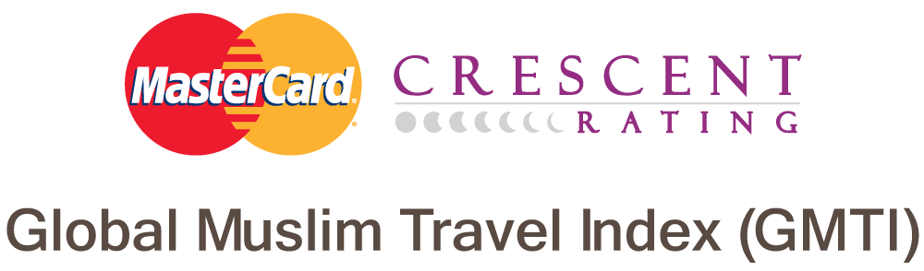
press information
USA Maintains Top 10 Spot in the MasterCard-CrescentRating Global Muslim Travel Index 2016
- USA keeps top 10 spot in among the non-OIC countries with Singapore keeping its number one spot.
- Malaysia topped the list for the second year running while the United Arab Emirates, Turkey, Indonesia and Qatar round off the top five OIC countries.
- Singapore is number one on the list of non-OIC countries, followed by Thailand, the UK, South Africa and Hong Kong.
- Asia and Europe are the two leading regions attracting Muslim visitors, accounting for 87 percent of the entire Muslim travel market.
- In 2015, the estimated total Muslim visitor arrivals were 117 million, representing 10 percent of the entire travel economy. This is expected to grow to 168 million travelers in 2020, spending over US$200 billion.
- https://www.crescentrating.com/mastercard-crescentrating-global-muslim-travel-index-gmti-2016.html
Jakarta, 23 March 2016 – USA has kept its spot in the top 10 most popular destinations in the global Muslim travel market, according to the most comprehensive research released on this the sector.
The MasterCard-CrescentRating Global Muslim Travel Index (GMTI) 2016, saw the USA drop two places from last year to tenth position on the list of non- Organisation of Islamic Cooperation (OIC) destinations.
Singapore retained its pole position for the non-OIC destinations, with Thailand, the UK, South Africa and Hong Kong making up the top five.
Malaysia kept hold of the top spot for OIC destinations with the UAE moving up to second place while Indonesia jumped two places to take the fourth spot.
The study also revealed that in 2015, there were an estimated 117 million Muslim visitor arrivals globally, representing close to 10 percent of the entire travel market. This is forecasted to grow to 168 million visitors by 2020 equal to 11 percent of the market segment with a market value projected to exceed US$200 billion.
Asia and Europe were also revealed as the two leading regions in the world for attracting Muslim visitors - accounting for 87 percent of the entire market.
“The MasterCard-CrescentRating Global Muslim Travel Index 2016 has now become the number one tool for destinations around the world to realign their strategies to reach out to the Muslim consumer. One of the biggest trends we are seeing is non-OIC destinations making a concerted effort to attract the Muslim tourist and they now represent over 63 percent of the destinations covered in the GMTI. For example, Japan and Philippines have taken some major steps over the last few months to diversify their visitor arrivals and boost their economy in the process,” said Fazal Bahardeen, CEO of CrescentRating & HalalTrip.
“Many already successful destinations around the world are looking to diversify their visitor base to maintain tourist growth rates in today’s increasingly competitive travel market. The fast growing Muslim travel segment is an opportunity in plain sight but in order to benefit from it, it is crucial to understand the needs and preferences of Muslim travelers and how to adapt and tailor products and services for them. We believe that the GMTI provides real value to businesses and governments looking to tap into this important market segment,” said Matthew Driver, Group Executive, Global Products & Solutions, Asia Pacific, MasterCard.
The GMTI 2016 is the most comprehensive research available on one of the fastest-growing tourism sectors in the world, which represents 10 percent of the entire travel economy.
The GMTI looks at in-depth data covering 130 destinations, up from 100 in 2015. This is the first time such thorough insights have been provided on one of the world’s fastest-growing tourism sectors.
The Index helps destinations, travel services and investors to track the health and growth of this travel segment while benchmarking their individual progress in reaching out to this growing market.
All 130 destinations in the GMTI were scored against a backdrop of criteria that included suitability as a family holiday destination, the level of services and facilities it provides, accommodation options, marketing initiatives as well as visitor arrivals.
Each criteria was then weighted to make up the overall index score. This year, two new criteria - air connectivity and visa restrictions - were added to further enhance the Index.
USA had an Index score of 48.9 placing it in 36th place in the overall combined ranking. Singapore scored 68.4 with Thailand posting 59.5. Malaysia had an Index score of 81.9 placing it at the top position in the overall combined ranking.
The overall average GMTI score for the complete 130 destinations currently stands at 43.7. From a regional perspective, Asia Pacific destinations lead with an average GMTI score of 56.5.
The top 10 non-OIC destinations in the GMTI 2016

RANK | GMTI 2016 RANK | DESTINATION | SCORE
1 | 8 | Singapore | 68.4
2 | 20 | Thailand | 59.5
3 | 21 | United Kingdom | 59.0
4 | 30 | South Africa | 53.1
5 | 31 | Hong Kong | 53.0
6 | 31 | France | 51.6
7 | 33 | Taiwan | 50.1
8 | 34 | Japan | 49.1
9 | 35 | Sri Lanka | 49.0
10 | 36 | United States | 48.9
The top 10 OIC destinations in the GMTI 2016
RANK | GMTI 2016 RANK | DESTINATION | SCORE
1 | 1 | Malaysia | 81.9
2 | 2 | United Arab Emirates | 74.7
3 | 3 | Turkey | 73.9
4 | 4 | Indonesia | 70.6
5 | 5 | Qatar | 70.5
6 | 6 | Saudi Arabia | 70.4
7 | 7 | Oman | 70.3
8 | 9 | Morocco | 68.3
9 | 10 | Jordan | 65.4
10 | 11 | Bahrain | 63.3

The full report is available here <insert hyperlink>.

END
For further information and interview requests, please contact:
Anas Kasak
CrescentRating
Tel: +44 7971 735090
Email: anas@crescentrating.com
Venture Liang
MasterCard
Tel: +65 6390 5973
Email: venture.liang@mastercard.com

Samantha Yong
Weber Shandwick
Tel: +65 6825 8053
Email: samyong@webershandwick.com
About CrescentRating Pte Ltd
CrescentRating is the world’s leading authority on halal-friendly travel. The company’s vision is to lead, innovate and drive this segment through practical and deliverable solutions in what is regarded today as one of the fastest growing segment in the tourism sector. The company uses insight, industry intelligence. lifestyle, behaviour and research on the needs of the Muslim traveller to deliver guidance on all aspects of halal-friendly travel to organisations across the globe.
CrescentRating’s services now include rating & accreditation, research & consultancy, workshops & training, ranking & indices, event support/partnerships and content provisioning.
Website: http://www.crescentrating.com
Twitter: http://twitter.com/crescentrating
LinkedIn: https://www.linkedin.com/company/crescentrating

About MasterCard
MasterCard (NYSE: MA), www.mastercard.com, is a technology company in the global payments industry. We operate the world’s fastest payments processing network, connecting consumers, financial institutions, merchants, governments and businesses in more than 210 destinations and territories. MasterCard’s products and solutions make everyday commerce activities – such as shopping, traveling, running a business and managing finances – easier, more secure and more efficient for everyone. Follow us on Twitter @MasterCardAP and @MasterCardNews, join the discussion on the Cashless Pioneers Blog and subscribe for the latest news on the Engagement Bureau.

